Feng Chia University

Electrical Engineering Fundamentals II Lab

Laboratory 7

OPAmp-T Network and Adjustable Gain

Instructor: Prof. Shyan-Lung Lin

Student Name: 周嘉禾

Student ID: D1166506

Experiment Date:25/04/2024

1. Introduction
2. To observe the behavior of Op Amp with T Network
3. Materials
   1. Power supply
   2. Digital Multimeter
   3. Function generator
   4. Devices

OPAmp: μA741

Resistors: R = 1kΩ×2, 2kΩ×2, 3kΩ×1, 10kΩ×2, 12kΩ×1, 20kΩ×1, 47kΩ×1

Variable Resistor: 10 kΩ×1

1. Circuit diagram

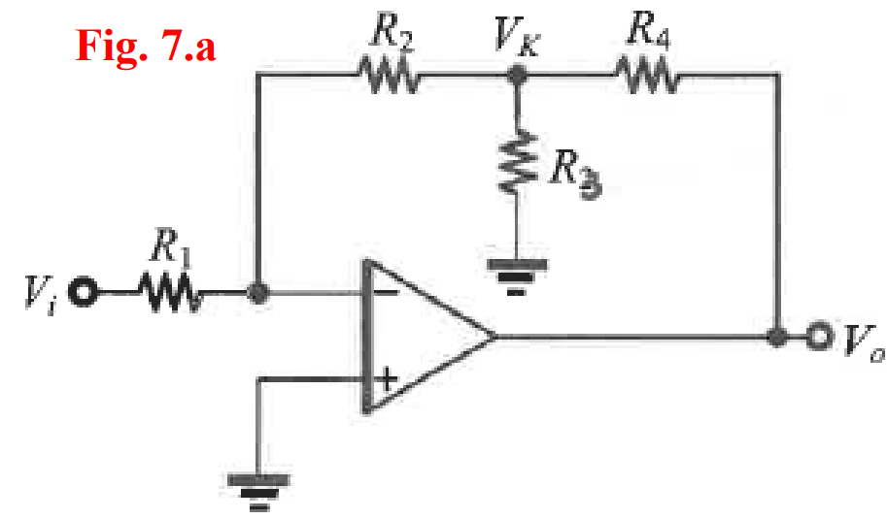

▲ Figure 1. Circuit of Experiment 7.a T Network

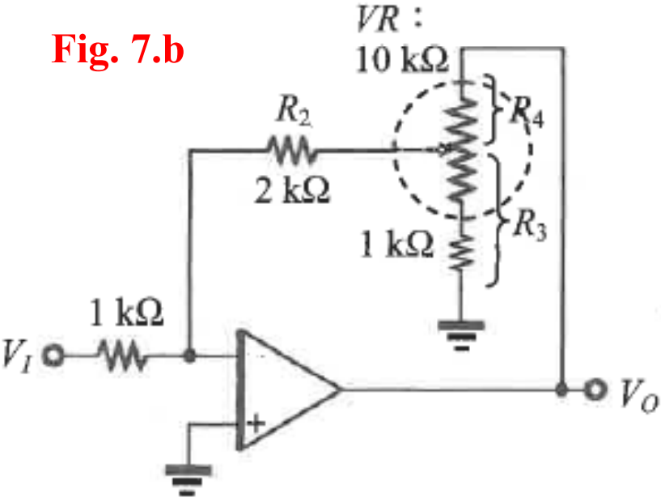

▲ Figure 2. Circuit of Experiment 7.b The Adjustable High-gain Amplifier

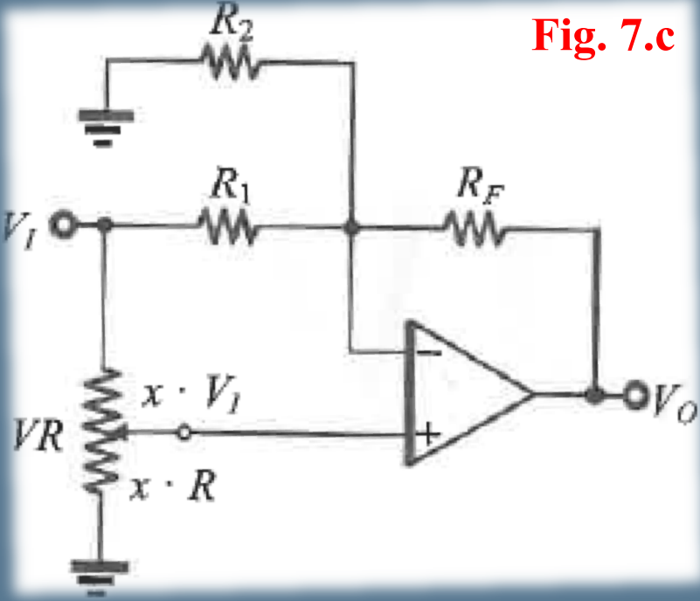

▲ Figure 3. Circuit of Experiment 7.c The adjustable Positive- and

negative-gain amplifier

1. Methods

Using Digital Multimeter to observe voltage.

1. Experiments data
   1. Experiment 7.a T Network

Table 1: Measurement of output voltages VO with fixed T Network

|  |  |  |  |  |  |  |  |
| --- | --- | --- | --- | --- | --- | --- | --- |
|  | DC | | | | AC f=1kHz | | |
| Vin | -0.1 V | -0.5 V | 0.1 V | 0.5 V | 0.1 V | 0.2 V | 0.5 V |
| Vo | 5.4987 V | 14.264 V | -5.3749 V | -12.952 V | 3.8457 V | 7.6783 V | 12.036 V |
| Gain | -54.987 V | -28.528 V | -53.749 V | -25.904 V | 38.457 V | 38.3915 V | 24.072 V |

* 1. Experiment 7.b The Adjustable High-gain Amplifier

Table 2: Measurement of gain with adjustable T Network

|  |  |
| --- | --- |
| The maximum gain | -2.0031 |
| The minimum gain | -12.875 |

* 1. Experiment 7.c The adjustable Positive- and negative-gain amplifier

Table 3: Measurement of adjustable Positive- and negative-gain

|  |  |  |
| --- | --- | --- |
|  | gain | ratio x |
| Theoretical | 3 | 0.875 |
| -3 | 0.125 |
| Measurement | 3 | 0.8307 |
| -3 | 0.1273 |

1. Results

None

1. Discussion

The Vo and gain of Op Amp with T Network will vary with the resistors.

1. Conclusion

From the experimental data above, the operational amplifiers work in an ideal situation.